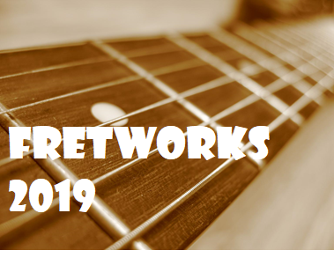 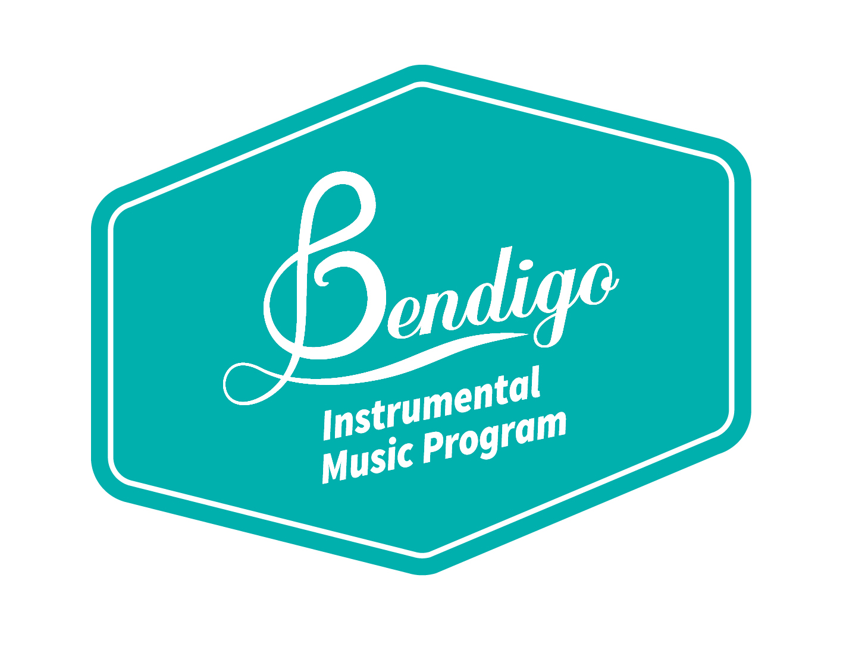

**Now into its eleventh consecutive year, The Bendigo Instrumental Music Program is celebrating eleven years of Fretworks. This educational event was created to offer guitar, bass and drum kit students an opportunity to be immersed in all aspects of contemporary and classical music, from exploring genre to composition and performance.**

**Students will take part in workshops where they will meet accomplished musicians and participate in rehearsals and activities that provide an ideal opportunity for students to develop their skills in a relaxed musical environment.**

**Fretworks will be held at Bendigo Baptist Church, 757 McIvor Hwy and culminates with students participating in the Fretworks Concert on the Thursday evening. This concert gives students the opportunity to present their achievements over the week.**

***Details***

**Date: Monday 16th – Thursday 19th of September 2019**

**Times: 8.45 am – 3.15 pm**

**Venue: Bendigo Baptist Church, 757 McIvor Hwy, Junortoun.**

**Cost: $110 per student\***

**What to bring: Instrument, amp, lead & music stand all labeled with**

**your name. Grey lead pencil and packed lunch.**

**Morning tea provided.**

**Dress: Neat Casual**

**Concert: 7pm on Thursday the 19th of September venue TBA.**

*Payment Details

Submit the completed registration form and deposit to the ***Business Manager’s Office*** at your child’s school before Friday the 16th of August. Final payment to be made by Friday the 6th of September. ***All cheques should be made payable to your school.***



**Frequently Asked Questions**

**When is Fretworks 2019?**

The final week of Term Three, **Monday 16th – Thursday 19th of September.**

**Where is Fretworks held?**

**Bendigo Baptist Church 757 McIvor Hwy, Junortoun**

**Does my child need to bring food?**

Yes. Students are required to bring their lunch, snacks and a water bottle each day as there will be no opportunity to purchase food.

**Can students go down the street to buy lunch, or order food to be delivered?**

No. We are unable to supervise these activities. Please send a packed lunch with your child. Students will not be permitted to leave the venue at any stage.

**Is there a bus to the camp?**

No, it is not possible for us to provide transport for students or to link with the other bus networks.

**Does my child wear school uniform to Fretworks activities?**

No, neat casual dress is acceptable for all daytime activities and for the final concert on Thursday evening.

**Where is the concert?**

Concert TBA

**Do I need tickets for the concert?**

No, please arrive early to secure a good seat. Gold coin donation is requested at the door.

**How much will Fretworks cost?**

$110 per student. We offer discounts for siblings. It is $90 per child to enroll for siblings.

**Can I pay in installments?**

To ensure a place in Fretworks, please pay in full or a $50 deposit by Friday the 16th of August then the remaining $60 is due by Friday the 6th of September.

***If you would like to discuss your child’s enrolment in Fretworks please contact***

***BIMP Co-coordinator: Mr Gavan Moncrieff.***

***Email:*** [***moncrieff.gavan.r@edumail.vic.edu.au***](mailto:moncrieff.gavan.r@edumail.vic.edu.au)

**Registration Form**

**Bendigo Instrumental Music Program’s - 11th Annual Fretworks**

Student’s Name: ­­­­­­­­ __________________________________________

School: _______________________________________ Year Level: _________

Medical Condition Details: _________________________________________________________

**Parent/Guardian’s Permission & Medical Consent.**

I give permission for my son/daughter to participate in Fretworks from Monday 16th to Thursday

19th of September at Bendigo Baptist Church, Junortoun.

* I am aware that Fretworks is a day only activity, and staff supervision is only available

between **8.45am** and **3.15pm** daily.

* I understand it is my responsibility to arrange transport to and from the venue.
* I understand that I must provide lunch for my child each day.
* I will provide details of any relevant medical condition concerning my participating child to the camp organisers.

In the event of an emergency, where it is impractical to communicate with the contact person indicated below, I give my consent for the teachers in charge to authorise whatever medical or surgical treatment

is deemed necessary for my son/daughter, and I agree to pay for this treatment.

Parent/Guardian’s Signature: _____________________________________

Name: (please print) ____________________________________________ Date: ___________

Please tick if your student has a medical action plan

Please tick if you **do not** wish for photographs of your student to be taken and used for publicity purposes.

**Contact Details for Students Attending Fretworks**

Name: ­­­­­­­­­­­­­­_____________________________________________ Home Phone Number: ________________________________

Email ______________________________________________

**Student Agreement**

I understand that I will not be able to leave the Fretworks venue during the day. I agree to act responsibility and follow instructions given to me, and I understand that failure to do so will result in my being sent back to school at my parent’s expense.

Student’s Signature: _________________________________________ Parents Signature: _________________________________________

At Fretworks 2019, we will run guitar ensembles and contemporary ensembles. Students will be allocated to an appropriate ensemble depending on their instrument and standard. All ensembles will be full time ensembles for the duration of the camp and students will receive both rehearsal time and tutorial time with their group.

Please list the instrument(s) you would like to play at Fretworks:

___________________________________________________