2024 ENROLMENT FORM
You can fill this form in and leave it with us at the Recruitment Night, or take it home to think about it for a couple of days.
It needs to be in the General Office by 9.00am Friday the 16/02/24
Once the information you provide is processed by the Music staff, this student will be enrolled in the Music Program, and a letter will be sent home explaining fee payments. Then the fun starts!

NAME________________________________________________FORM___________

Have you learnt an instrument before? | Yes |  | No |  | Note: this is NOT a requirement. No experience necessary.

If you ticked Yes: Which instrument have you learnt

How many years have you learnt this instrument for? (approx)

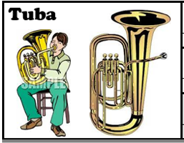
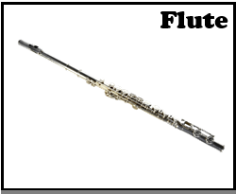
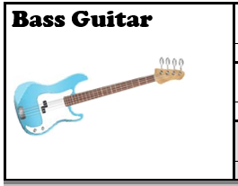
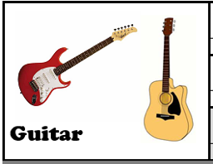
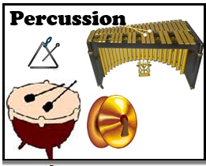
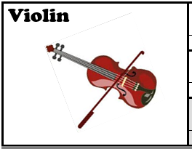
Here are the instruments you can learn at school
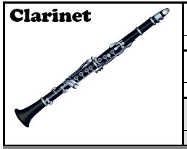
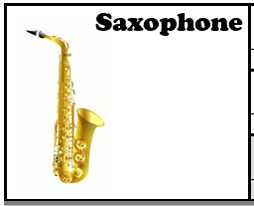
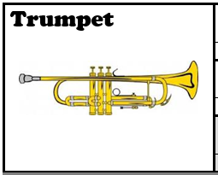
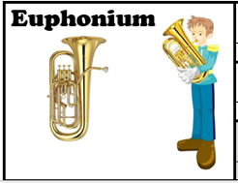
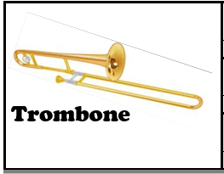
CHOOSE YOUR THREE FAVOURITE INSTRUMENTS. The Music teachers will choose one for you, based on your instrument try-out scores and overall availability.

- ______________________________________________________

- ______________________________________________________

- ______________________________________________________

See over the page for more information

Parents, how will an instrument be provided for the student? Please tick one box.

 |  | We wish to hire an instrument from the school for $100.00 per year.
 |  | A Hire Agreement Form will be sent home next week, along with the letter telling you which instrument we have selected for you.
 |  | We are planning to purchase an instrument.
The letter we send home next week will tell you your child’s Instrumental Music Teacher’s name. Please ask this teacher for advice on which brand(s) to purchase, and which businesses to purchase from.
BUYER BEWARE. There are many poor quality brands on the market. Buying a bad instrument makes learning difficult for the student and wastes parents’ money. Ebay is NOT recommended.

 |  | We already own an instrument.
 |  | Instrument |  | Brand
 |  | Model (if known) |  | Age (approx)
 |  | Please bring the instrument to the first lesson for the Music teachers to check its quality and condition.

Time commitments – Student’s agreement
I agree to keep up the following commitments for this full school year:
- Regular home practice: 15-minute sessions, 5 times per week.
- Attendance at a weekly instrumental lesson during school time.
- Attendance at a weekly ensemble rehearsal.
- Attendance at ensemble performances during the year, out of school hours.
- Attendance at a weekly instrumental lesson during school time.
- Attendance at ensemble performances during the year, out of school hours.
Signature of student
Parent’s agreement
I support the commitment my child is making (above) to join the Instrumental Music Program for this full school year.
I agree to:
- Arrange transport to weekly rehearsals and occasional concerts out of school hours.
- Provide my child with appropriate time and space to practise regularly at home.
- Ensure that my child takes proper care of the instrument.
- Provide lots of encouragement, and assist my child to meet the Student’s Agreement listed above.
Signature of Parent
Information on Fees

The Instrumental Music subject fee is $180.00 for the year.
All students in the Music Program must pay this fee to the general office, by end of Term One

The hire fee is $100.00 for the year. Students who wish to hire an instrument from the College should pay an instalment of $50.00 by the end of Term One . The balance will be due by the end of Term Two

